/******************************************************************************

* WebGen Suite *

* __ __ __ ______ *

* |\ \ _ |\ \ |\ \ /\ \ *

* | $$ /\\ | $$ ______ | $$____ |\ $$$$$$\ ______ _______ *

* | $$/ $\| $$ /\ \ | $$ \ | $$ __\$$ /\ \ |\ \ *

* | $$ $$$\ $$|\ $$$$$$\| $$$$$$$\| $$|\ \|\ $$$$$$\| $$$$$$$\ *

* | $$ $$\$$\$$| $$ $$| $$ | $$| $$ \$$$$| $$ $$| $$ | $$ *

* | $$$$ \$$$$| $$$$$$$$| $$__/ $$| $$__| $$| $$$$$$$$| $$ | $$ *

* | $$$ \$$$ \$$ \| $$ $$ \$$ \ $$ \$$ \| $$ | $$ *

* \$$ \$$ \$$$$$$$ \$$$$$$$ \$$$$$$ \$$$$$$$ \$$ \$$ *

* *

*******************************************************************************

**WebGen Suite *User Manual***

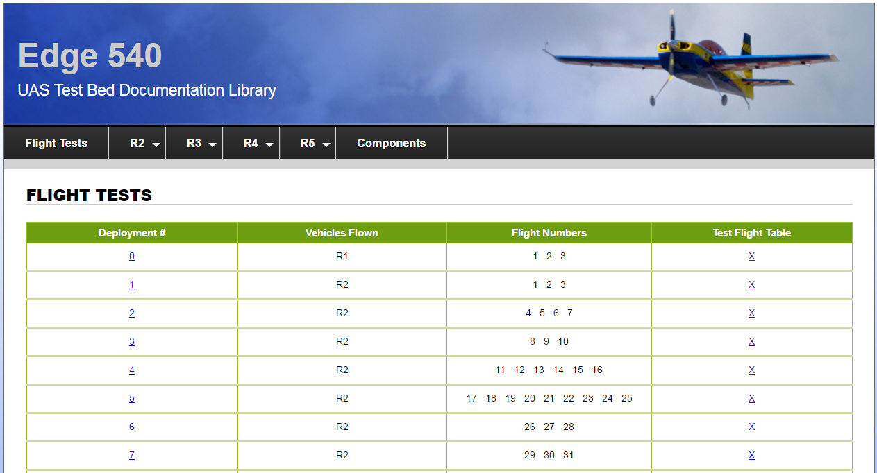

Table of Contents

Section 1: What’s included? Pg. 3

Section 2: WebGen Pg. 4

Section 3: Link Checker Pg. -

Section 4: Compare Directories

Section 1: What’s included?

The WebGen Suite is the comprising of multiple standalone software packages. In general, software included has been developed for the purpose of automatic generation and verification of the website for the Edge 540 Unmanned Aerial Systems branch at NASA Langley Research Center. The packages and there general functions are as follows:

WebGen:

Automate creation of the Flight Data website with the various pages utilizing digital deployment and flight data folders.

Link Checker:

Given a start page, it recursively checks linked pages and generates a report stating the status of each link and a page that it is found on.

Compare Directories:

Compares the contents of two directories with high customizability settings to ensure that all files that exist in directory x also exist in y.

Delete Empty Directories

Recursively checks directories from a given start folder and deletes the directory if it contains no files or folders.

Section 2: WebGen